Team ABLE Project Report

Able | Able Wars

Prog 35142

Abdullah, Auquib, Avery, Bilal, Enzo, Levon

2016

**Access**

To run ABLE Wars and view the .NET portion of the capstone, you will have to access game portion of the site and register an account, <http://142.55.32.86:50121/> will let you access the game. If you want to go to the leaderboard page manually: <https://142.55.32.86:50122/AWStats>.

**Proof of Concept**

The project is being deployed through IIS. Due to outrageous configurations getting a node application to function in IIS, we were unable to throw both applications in the same website so we used two different ports, one being HTTP and the other being HTTPS without any certifications (so warnings may occur). We were trying to implement other enhanced functionalities for the administrator of the leaderboard page to create, update and delete but due to a time constraint and dealing with the complications of individual user authentications with WebAPI we have decided to leave this functionality aside.

**Notes**

As of now, the gameplay and leaderboard applications are fully functional and intercommunicative providing all the necessary components to represent a game with full statistical and comparative functionality. We have in fact also already used our report to discover a previously invisible yet major flaw in out statistics system. Using the information in our report we were able to deduce the exact cause of and solution to this flaw. Also while taking note of the information supplied to us by our report, we were able to create a passive solution which would not disrupt the data and statistics currently recorded, and will correct itself over time, whenever a user whose account is affected by the error is used, thereby making the solution’s implementation seemingly and relatively instant to each user.

**Lessons Learned**

The biggest lesson learned was problem solving for deployment of two separate applications of different technologies, bases, and conflicting web configurations. Also a solidified understanding of .NET deployment.

**Report PDF Output**

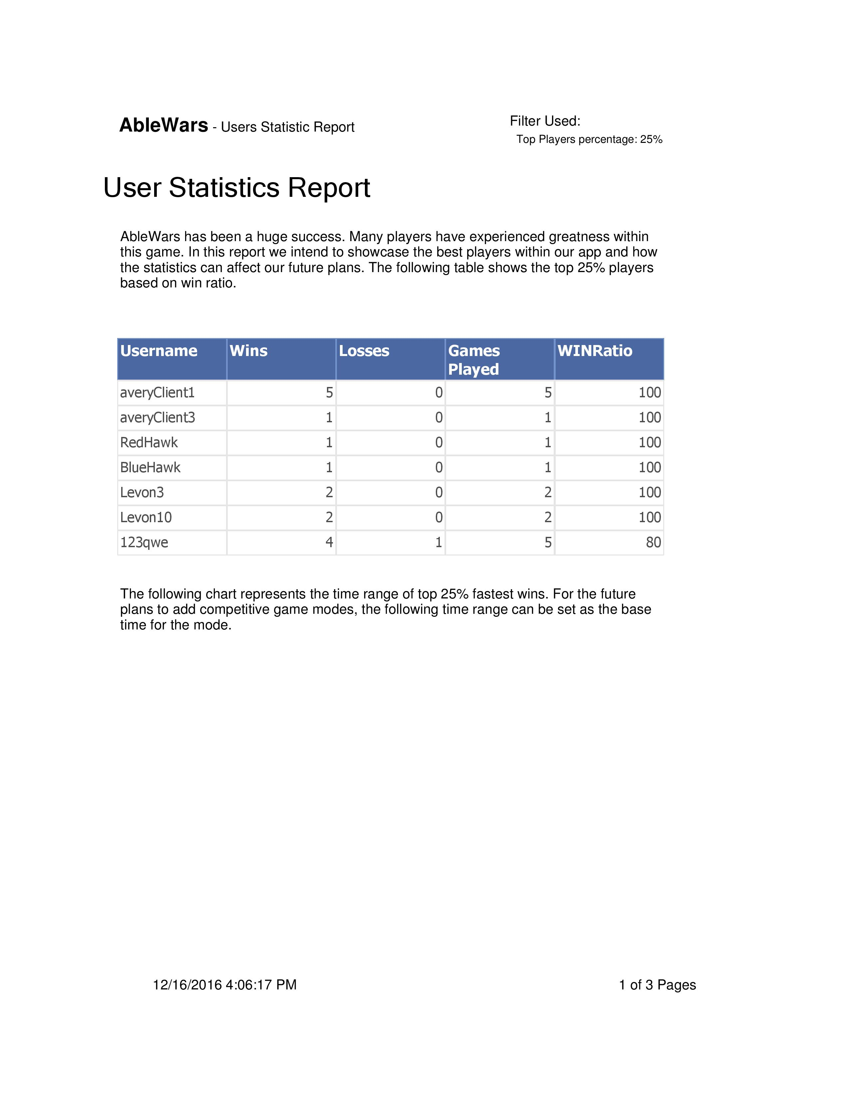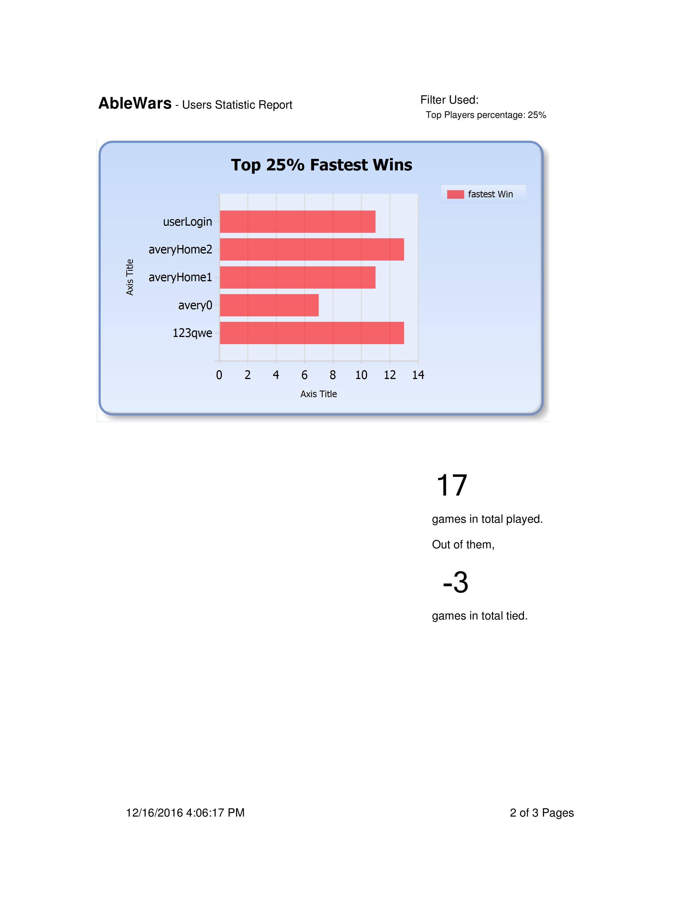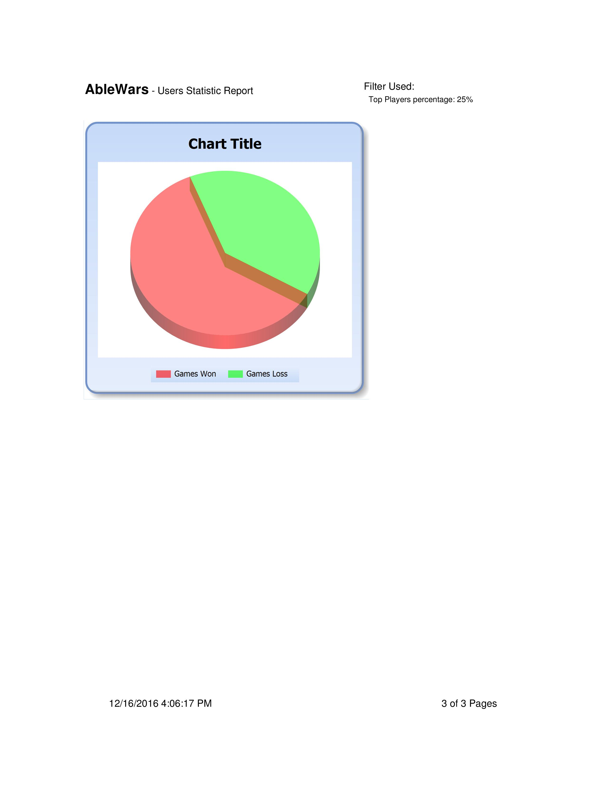

**Screenshots**(alternatively see “screenshots” directory)

